**Part 1**

**Code**

**#PART 1**

**#The circumference of a circle is calculated by 2πr, where π = 3.14159 (rounded to five decimal places).**

**#Write a function called print_circum that takes an argument for the circle’s radius and prints the circle's radius.**

**def print_circum(r):**

**pi = 3.14159**

**circumference = 2*pi*r**

**return circumference**

**#Call your print_circum function three times with different values for radius.**

**print("The circle circumference is: ",round(print_circum(3),5))**

**print("The circle circumference is: ",round(print_circum(6),5))**

**print("The circle circumference is: ",round(print_circum(9),5))**

**#the round function helps us to reduce the number after the period, I selected a maximum of 5 digits after the period**

**OUTPUT**

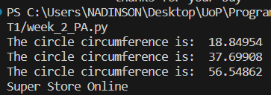

**Part 2**

**Code**

**def purchase(): #this function shows the catalog of the store**

**product_1 = "Item 1" # name of the Item**

**price_1 = 200 #Item´s price**

**product_2 = "Item 2"**

**price_2 = 400**

**product_3 = "Item 3"**

**price_3 = 600**

**product_c1 = "Combo 1 (Item 1 + Item 2)"**

**price_c1 = int((price_1 + price_2) - (price_1 + price_2)*10/100) # With this expression is calculated the sum of item 1 and item 2 less the 10%**

**product_c2 = "Combo 2 (Item 2 + Item 3)"**

**price_c2 = int((price_2 + price_3) - (price_2 + price_3)*10/100)# With this expression has calculated the sum of item 2 and item 3 less the 10%**

**product_c3 = "Combo 3 (Item 1 + Item 3)"**

**price_c3 = int((price_1 + price_3) - (price_1 + price_3)*10/100) # With this expression is calculated the sum of item 1 and item 2 less the 10%**

**product_c4 = "Combo 4 (Item 1 + Item 2 + Item 3)"**

**price_c4 = int((price_1 + price_2 + price_3) - (price_1 + price_2 + price_3)*25/100) # With this expression is calculated the sum of item 1, item 2 and item 3 less the 25%**

**print(" ") # using the print function can I diagram the structure of the catalogue**

**print("_________________________________________________")**

**print("Super Store Online") # name of the store**

**print("-------------------------------------------------")**

**print("Product(s) Price")**

**print(product_1," ",price_1)**

**print(product_2," ",price_2)**

**print(product_3," ",price_3)**

**print(product_c1," ",price_c1)**

**print(product_c2," ",price_c2)**

**print(product_c3," ",price_c3)**

**print(product_c4," ",price_c4)**

**print("_________________________________________________")**

**print(" Delivery Contact: +57 302338472")**

**print(" thanks for your buy ")**

**purchase()**

**Output**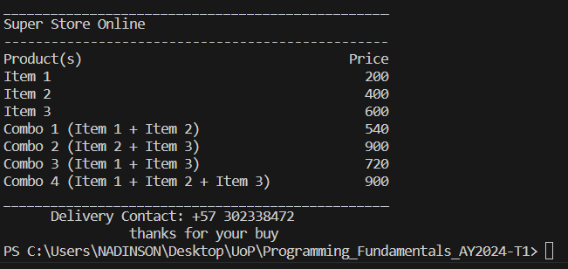

**Screenshot**

